LOCATION : NATIONWIDE
DATE : 13.01.2017
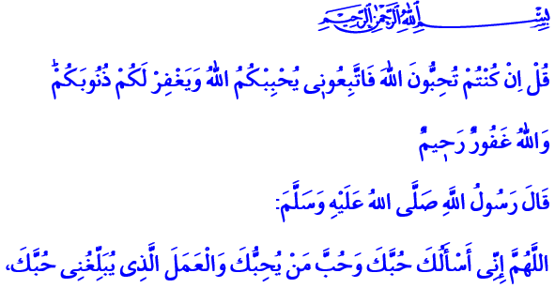
TO BE ABLE TO BE A SERVANT ALLAH LOVES
A Blessed Friday to You, Brothers and Sisters!
In the verse I have recited, Allah Almighty shows us the way to be honored with His love and favor: “Say, [O Muhammad], ‘If you should love Allah, then follow me, so Allah will love you and forgive you your sins. And Allah is Forgiving and Merciful.’”
Brothers and Sisters!
The Almighty stated the deeds that will move us away from His grace in His Book like He showed us in it the ones that will bring us to His favor. He stated the ones honored with His love as well as those left without His love and mercy. Come, let’s hear in today’s khutbah who the servants our Lord loves are.
وَاللّٰهُ يُحِبُّ الْمُطَّهِّر۪ينَ Allah loves those pure in the spiritual and material sense. Then come, let’s protect our disposition against all evil. Let’s make our mind and our heart the center of goodness and nice things, not of evil and ugliness.
اِنَّ اللّٰهَ يُحِبُّ التَّوَّاب۪ينَ Allah loves those who repent. Then, honorable brothers and sisters! Come, let’s be the servants we are and repent. Let’s voice our submission to our Lord and the remorse for our sins. Let’s take refuge in His vast mercy. Let’s not forget that repentance is like a new start to life.
اِنَّ اللّٰهَ يُحِبُّ الْمُتَّق۪ينَ Allah loves those who avoid disobey Him. Then come, let’s always be aware of our duties and obligations towards Him. Let’s live our lives in accordance with the purpose and reason of our creation.
اِنَّ اللّٰهَ يُحِبُّ الْمُتَوَكِّل۪ينَ Allah loves those who trust Him. Then come, after doing our duty, حَسْبُنَا اللّٰهُ وَنِعْمَ الْوَك۪يلُ let’s say “Allah suffices, what a great trustee He is!” Let’s never lose hope in our Lord’s grace, help, and blessing.
وَاللّٰهُ يُحِبُّ الْمُحْسِن۪ينَۚ Allah loves the doers of good and those who seek His favor in everything they say and do. Then come, brothers and sisters! Let’s act with the awareness that our Lord sees us at every moment.
وَاللّٰهُ يُحِبُّ الصَّابِر۪ينَ Allah loves the patient. He is with the patient. Then come, let’s adopt patience and quiet as a maxim with the awareness that life is a test.
اِنَّ اللّٰهَ يُحِبُّ الْمُقْسِط۪ينَ Allah loves who are just. Then come, let’s elevate justice at all times. Let’s not forget that justice is the key to trust and peace. It is indispensable for a humane life.
Dear Brothers and Sisters!
Come, now look at those the Almighty does not love.
اِنَّ اللّٰهَ لَا يُحِبُّ الْمُعْتَد۪ينَ Allah does not love aggressors, those who cross the line. Then, we must be constructive and unifying, not destructive and divisive.
وَاللّٰهُ لَا يُحِبُّ الظَّالِم۪ينَ Allah does not love the oppressors. Because oppression is one of the biggest sins. It means disregarding what’s right and just. Then, we must always stand against the oppressors and with the oppressed.
اِنَّهُ لَا يُحِبُّ الْمُسْرِف۪ينَۙ Allah does not love the prodigals. Then, we must avoid squandering what we have earned and lavishly using the blessings Allah has bestowed upon us.
وَاللّٰهُ لَا يُحِبُّ الْمُفْسِد۪ينَ Allah does not love those who spoil and make trouble. Then, we must altogether protect our peace, our unity and togetherness, our brotherhood and relationship.
اِنَّهُ لَا يُحِبُّ الْمُسْتَكْبِر۪ينَ Allah does not love the arrogant, those who boast. Then, we must elevate with humility and solemnity.
اِنَّ اللّٰهَ لَا يُحِبُّ الْخَٓائِن۪ينَ۟ Allah never loves those who betray Himself, His Holy Book, His Prophet, their own values, and their own brothers. Then, we must stay away from all sorts of betrayal, hypocrisy, and deception.
وَاللّٰهُ لَا يُحِبُّ كُلَّ كَفَّارٍ اَث۪يمٍ Allah does not love anybody who persists in impiety and sin. Then, we must avoid being blind and oblivious to the countless blessings bestowed upon us by the Almighty and the goodness we have been blessed with.
Brothers and Sisters!
May the Almighty Lord grant us to be among those happy servants of His who have been honored with His love. As I conclude my khutbah, I would like to share with you this piece of information: As they always do, our great nation has shown great favor to the aid campaign launched by the Presidency of Religious Affairs a short while ago with the slogan “Don’t Let Humanity Die in Aleppo.” Under the campaign, an aid of 133,745,000 TL has been raised so far from abroad and within the country. The raised fund is sent to our oppressed brothers and sisters in Aleppo to tend to their wounds. May the Almighty accept your help. May He always protect our country and our great nation that are the hope of the oppressed, the downtrodden, and the destitute.

Ali ‘Imran, 3/31. Written by: General Directorate of Religious Services

